🡪 Block Name = GENERIC_GRAPH

A Graph component is built based on a table structure. The idea is to fill data into the table of the graph to populate it automatically. The table structure is the same as of the Generic table component:

**Axis & values**

List of AXIS List of TAGS per Axis

METRICS

RUN_TIME

TECHNICAL_DEBT

CRITICAL_VIOLATION

VIOLATION

TECHNICAL_SIZING

FUNCTIONAL_WEIGHT

<ID>

HEALTH_FACTOR

BUSINESS_CRITERIA

TECHNICAL_CRITERIA

QUALITY_RULES

APPLICATIONS

EACH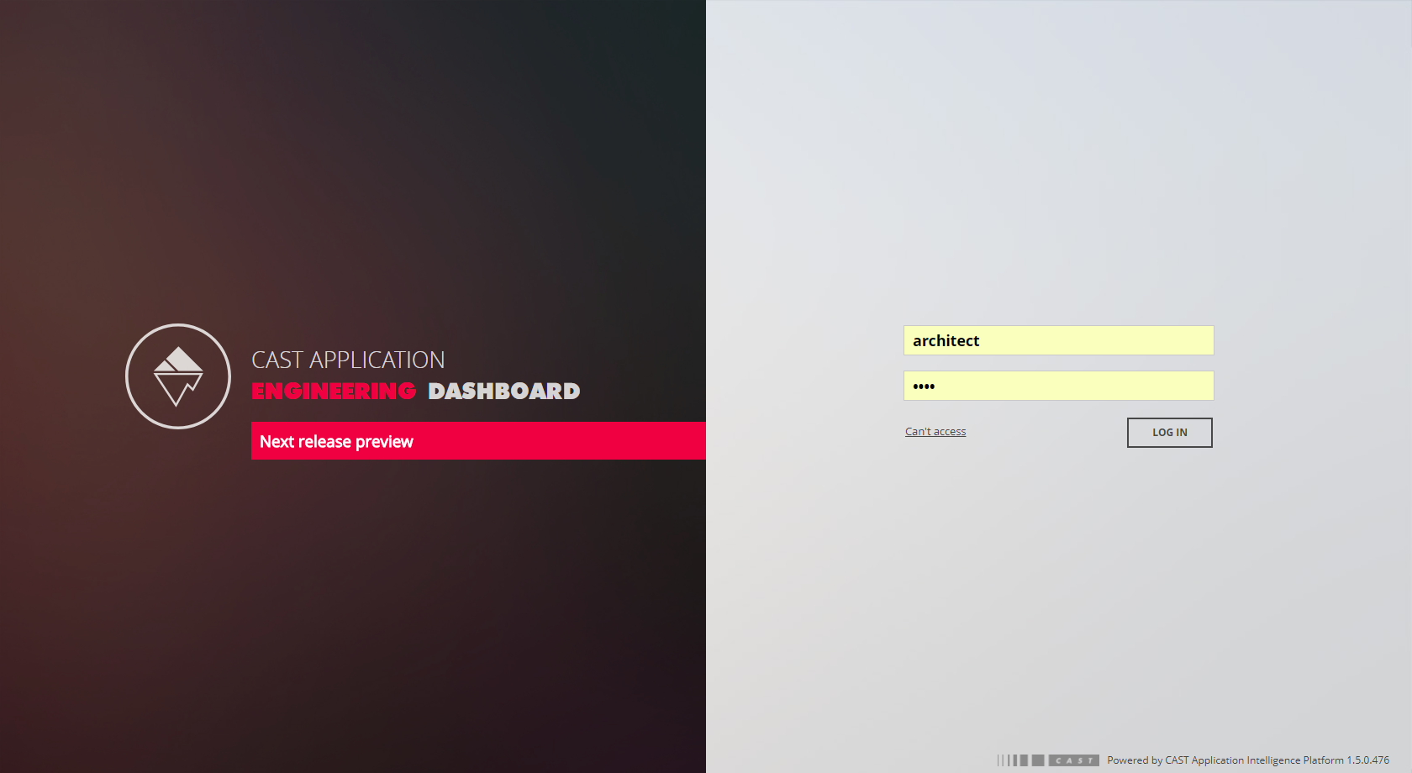

ALL

<NAME>

VIOLATIONS *

ALL

REMOVED

ADDED

TOTAL

CRITICAL VIOLATIONS *

TOTAL

ALL

ADDED

REMOVED

TECHNOLOGIES

EACH

<NAME>

* To get results on violations or critical violations on a specific metrics, add the axis “METRICS=M” where M is a metric id from quality model (eg page 4)

**Table Structure**

COL 1: (1st axis of information, mandatory)

ROW 1: (1st axis of information, mandatory)

COL 11: (2nd axis of information, optional)

ROW 11: (2nd axis of information, optional)

|  |  |  |  |  |
| --- | --- | --- | --- | --- |
|  | COL1 – COL11 | COL1 – COL12 | COL2 - COL21 | COL2 - COL22 |
| ROW1 |  |  |  |  |
| ROW11 |  |  |  |  |
| ROW12 |  |  |  |  |
| ROW2 |  |  |  |  |
| ROW21 |  |  |  |  |
| ROW22 |  |  |  |  |

**“Alt” Structure (without space or return)**

TABLE;GENERIC_TABLE;COL1=A,COL11=B,ROW1=C,ROW11=D,A=a,B=b,C=c|d,D=e|f|g

* where A,B,C and D are one of the axis above
* and a, b, c, d, e, f, g is one or multiple tags of the axis
* AGGREGATORS

**Clustered column graph – sample 1**

GRAPH;PF_GENERIC_GRAPH;COL1=METRICS,ROW1=APPLICATIONS,METRICS=60016

**Clustered column graph – sample 2**

GRAPH;PF_GENERIC_GRAPH;COL1=METRICS,ROW1=TECHNOLOGIES,METRICS=10151|60017,AGGREGATORS=SUM|AVERAGE,TECHNOLOGIES=EACH

**Stacked Bar – sample 3**

GRAPH;PF_GENERIC_GRAPH;COL1=CRITICAL_VIOLATIONS,ROW1=APPLICATIONS,APPLICATIONS=ALL,CRITICAL_VIOLATIONS=ALL,METRICS=60017

**Stacked Bar – sample 4**

GRAPH;PF_GENERIC_GRAPH;COL1=CRITICAL_VIOLATIONS,ROW1=METRICS,METRICS=HEALTH_FACTOR,CRITICAL_VIOLATIONS=ADDED|REMOVED

**Radar chart – sample 5**

GRAPH;PF_GENERIC_GRAPH;COL1=APPLICATIONS,ROW1=METRICS,METRICS=60013|60014|60016,AGGREGATORS=AVERAGE,APPLICATIONS=ALL

**Pie chart – sample 6**

GRAPH;PF_GENERIC_GRAPH;ROW1=TECHNOLOGIES,COL1=METRICS,TECHNOLOGIES=EACH,METRICS=10151,AGGREGATORS=SUM